Name of the teaching Staff | Dr. Radha Das |  |  | 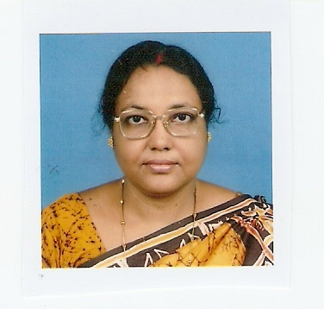ph
Designation: | Dean (CHE, BT, FT) & Professor
Department: | Chemical Engg.
Mobile No.: 9434453157 | Email-id: radha.das6@gmail.com
Date of Joining the Institution: | 07. 11. 1998
Qualification with Class Grade | UG |  | PG | PhD, Post Doc.
 | Ist Class |  | Ist Class | Awarded in 2000 , 2008
Total Experience in years | Teaching |  | Industry | Research
 | 21 yrs |  | 1 yr | 21 yrs.
Papers Published | National/ International (Conf) |  |  | International (Journal)
 | 53 |  |  | 20
Books Published/IPRs/ Patents | Book Chapter Published on :  i) Modeling of Indirect photo-transformation Reactions in Surface  Waters” published by WILEY-VCH, Published 2010  ii) Bicarbonate‐enhanced Photocatalytic Degradation of Phenol : Competition with excess Organic Matter” as Principal author , Published by WILEY-VCH in 2013  iii) One Patent applied, No. 6/KOL/2011 dated 3.1.2011 ,  (A process for removal of colour from crude Fatty Acids)
Professional Memberships | - Life member of Indian Institute of Chemical Engineers  - Life member of Institute of Engineers India.(IEI)  - Life member of Indian Society for Technical Education (ISTE)  - Life Members of Enviro Media.
Consultancy Activities | - “Safe Disposal and /or Recovery of Chemicals from Solid Waste”, for Exide Battery Plant at Haldia, Purbo Medinipur, W.B  - A process for removal of color from crude Fatty Acids” for Rosui Chemicals Ltd. Haldia .
Awards | 1. Best Teacher Award 2017 from Maulana Abulkalam Azad University of Technology  2. Institutional Medal for best paper from Engineer's India IEI , 2000  3. Best paper award from Annual Congress Of IIChe , Chemcon’96  4. Won Gold Medal for 1st Class 1st position in M.Tech from Calcutta  University.  5. Received Certificate of Merit from Engineer's India IEI , 2008
Interaction with Professional Institutions | - National Council Member of IIChE (2015-17).  - Hony. Registrar IIChE , 2015-2016  - Former Vice Chairperson of HRC, IIChE & Founder Secretary of Haldia Regional Centre of IIChE

