Name of Teaching Staff: | Meenakshi Dey |  | 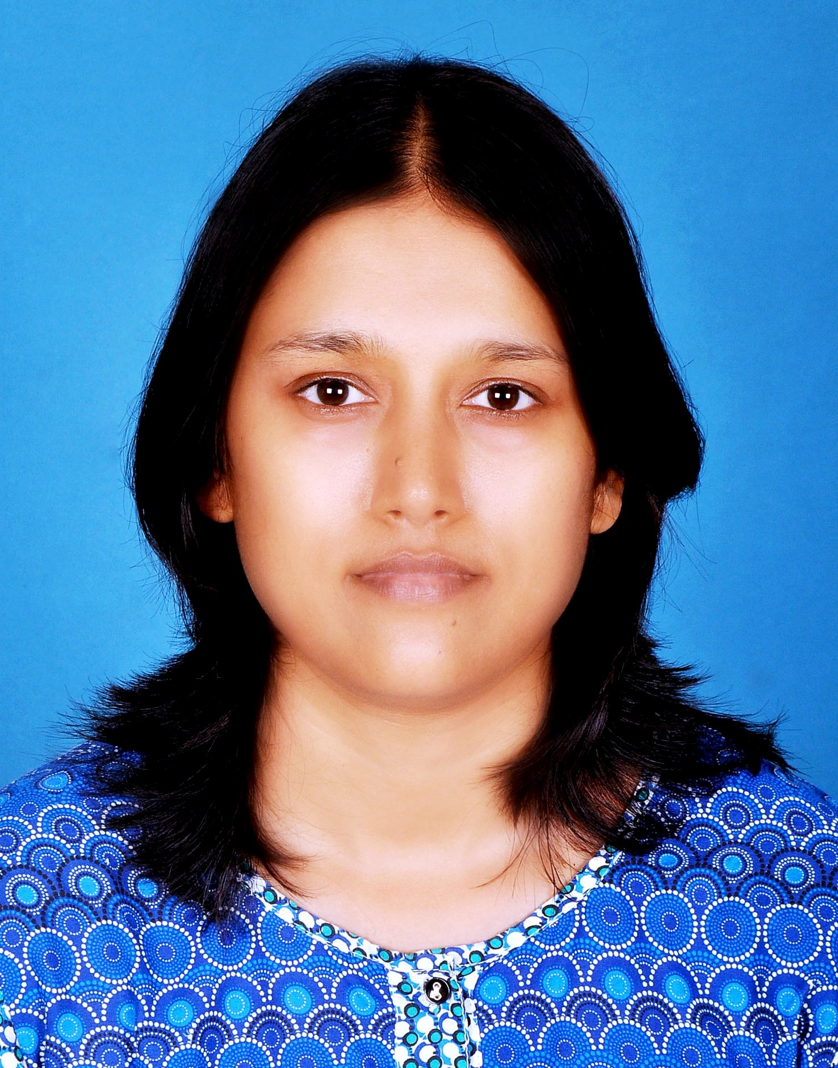
Designation: | Assistant Professor, English
Department: | School of Applied Sciences & Humanities
Date of Joining the Institution: | 07/02/08
Qualification with Class Grade | UG | PG | PHD
 | B.A. (Eng Hons.)  IInd Div. | M.A(Eng.)  IInd Div. | Pursuing from Vidyasagar Univ., Midnapore, W.Bengal
Total Experience in years | Teaching | Industry | Research
 | 16
Papers Published | National |  | International
 | 2 |  | 2
PhD Guide? Give field & University | Field |  | University
 | N.A.
PhDs/ Projects Guided | PhDs: |  | Projects at Masters Level
 | N.A |  | N.A.
Books Published/IPRs/ Patents
Professional Memberships | N.A.
Consultancy Activities | N.A
Awards | Qualified UGC NET Exam on 15th June 2015.
Grants Fetched | N.A
Interaction with Professional Institutions | N.A.

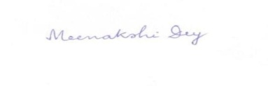
18.01.2017
(Signature with date)

