Name of Teaching Staff: | Sarbari Samanta |  | 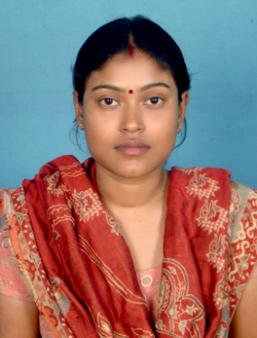
Designation: | Assistant Professor
Department: | School of Applied Science & Humanities
Date of Joining the Institution: | 21.08.2007
Qualification with Class Grade | UG | PG | PHD
 | 2nd | 1st | Pursuing
Total Experience in years | Teaching | Industry | Research
 | 9 yrs |  | 2 yrs
Papers Published | National |  | International
PhD Guide? Give field & University | Field |  | University
PhDs/ Projects Guided | PhDs: |  | Projects at Masters Level
Books Published/IPRs/ Patents
Professional Memberships | The Indian Science Congress Association, Calcutta Mathematical Society
Consultancy Activities
Awards
Grants Fetched
Interaction with Professional Institutions

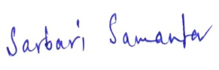
18.01.2017
(Signature with date)

