Name of Teaching Staff: | NIBADITA PURKAIT |  | 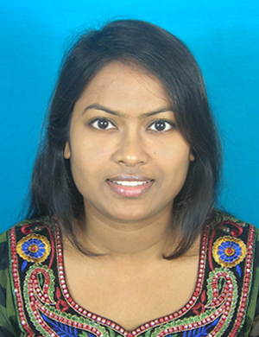
Designation: | Assistant Professor
Department: | Applied Science
Date of Joining the Institution: | 09.07.2015
Qualification with Class Grade | UG | PG | PHD
 | 1st | 1st | 1st
Total Experience in years | Teaching | Industry | Research
 | 1 | 0 | 2
Papers Published | National |  | International
 | 0 |  | 4
PhD Guide? Give field & University | Field |  | University
PhDs/ Projects Guided | PhDs: |  | Projects at Masters Level
Books Published/IPRs/ Patents
Professional Memberships
Consultancy Activities
Awards
Grants Fetched
Interaction with Professional Institutions

