Name of Teaching Staff: | DR. BALARAM DEY |  | 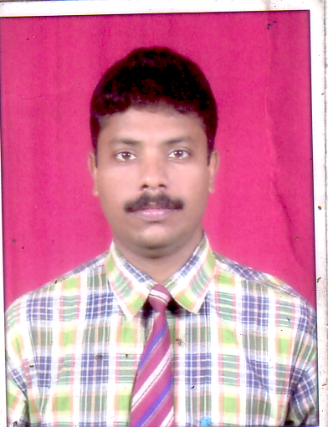
Designation: | ASSOCIATE PROFESSOR
Department: | PRODUCTION ENGINEERING
Date of Joining the Institution: | 21 July 2008
Qualification with Class Grade | UG | PG | PHD
 | AMIE ( 57.6%) | ME (Hons.) 75.6% | Ph.D. (Engg.), Jadavpur University, Kolkata.
Total Experience in years | Teaching | Industry | Research
 | 12 | 4 | 6 Yrs. 8 months
Papers Published | National |  | International
 | - |  | 10(Journals) +  4(Conference)
PhD Guide? Give field & University | Field |  | University
 | _ |  | -
PhDs/ Projects Guided | PhDs: |  | Projects at Masters Level
 | - |  | -
Books Published/IPRs/ Patents | Nil
Professional Memberships | Fellowship (F-1231304) from The Institution of Engineers(India)
Consultancy Activities | Nil
Awards | Nil
Grants Fetched | Nil
Interaction with Professional Institutions | 1. Reviewer, Computers and Industrial Engineering(CAIE), ELSEVEIR;  2. Reviewer, International Journal of Management Science and Engineering Management (IJMSEM), Taylor & Francis;  3. Reviewer, International Journal of Computational Intelligence Systems (IJCIS).

