Name of Teaching Staff: | Manas Kumar Bhukta |  | 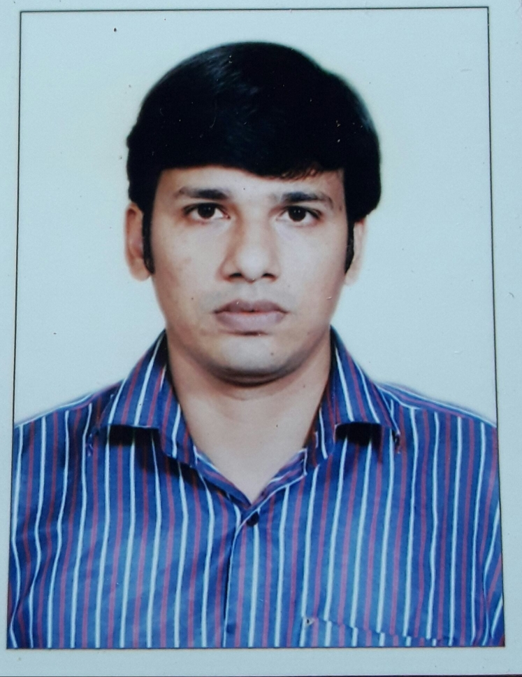
Designation: | Asst. Professor
Department: | Mechanical Engineering
Date of Joining the Institution: | 01/08/2016
Qualification with Class Grade | UG | PG | PHD
 | B. Tech, 1st | M.Tech., 1st | NA
Total Experience in years | Teaching | Industry | Research
 | 12 Months | 4 years | 01
Papers Published | National |  | International
 | NA |  | NA
PhD Guide? Give field & University | Field |  | University
 | NA |  | NA
PhDs/ Projects Guided | PhDs: |  | Projects at Masters Level
 | NA |  | NA
Books Published/IPRs/ Patents | NA
Professional Memberships | NA
Consultancy Activities | NA
Awards | NA
Grants Fetched | NA
Interaction with Professional Institutions | NA

