Name of Teaching Staff: | Apratim Mitra |  | 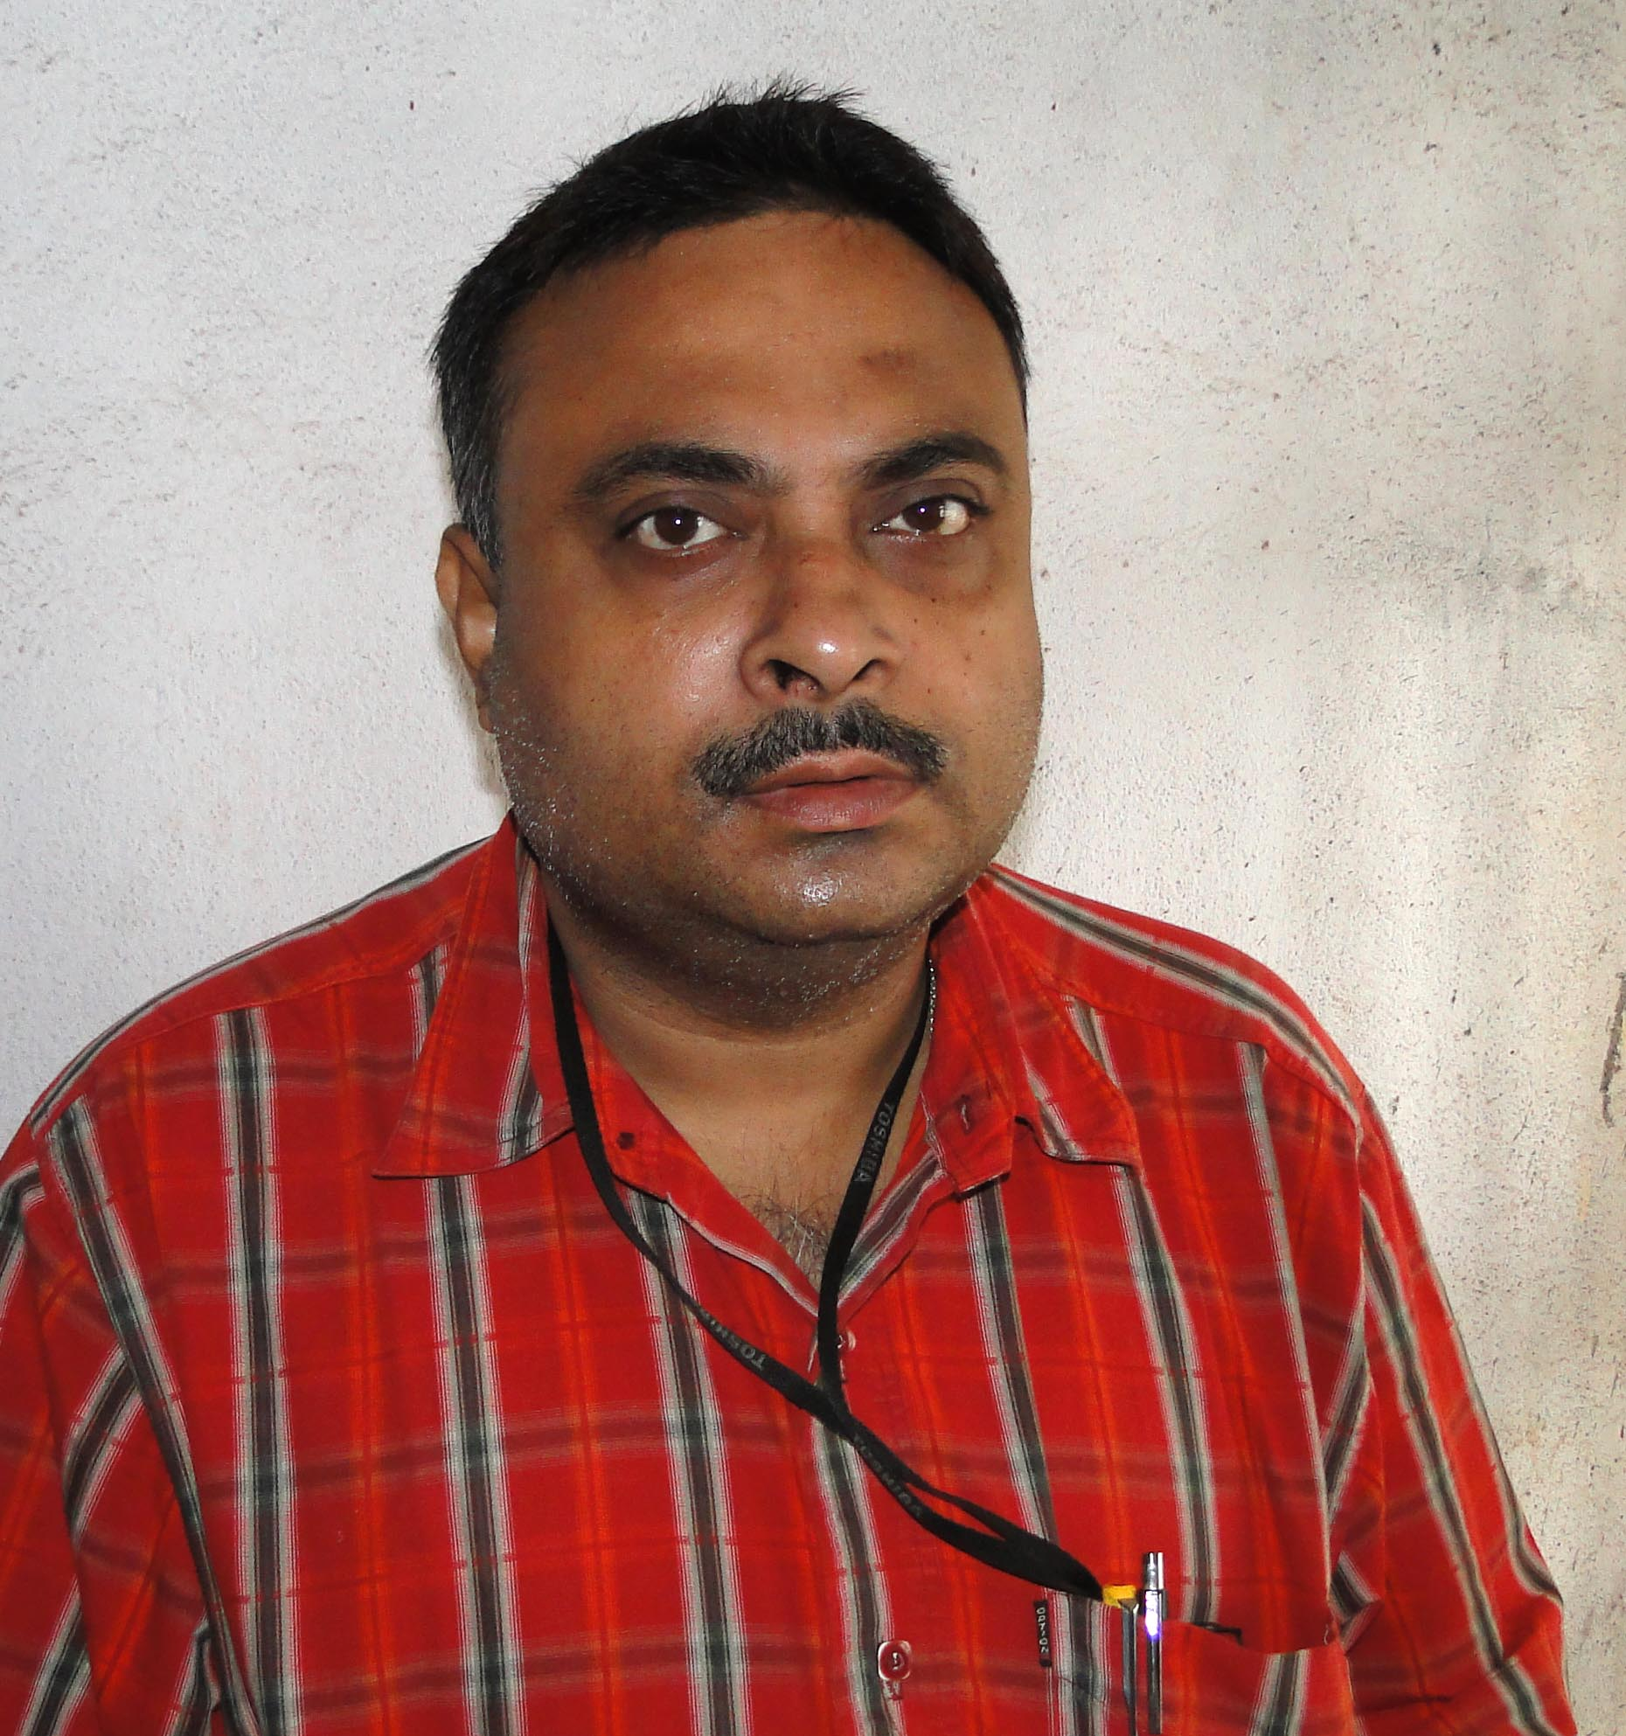
Designation: | Associate Professor
Department: | Computer Applications
Date of Joining the Institution: | 01.02.2002
Qualification with Class Grade | UG | PG | PHD
 | B.Sc(Hons.) | MCA | Pursuing
Total Experience in years | Teaching | Industry | Research
 | 14 | 5 and ½ Yrs | 1
Papers Published | National |  | International
 | 5 |  | 1
PhD Guide? Give field & University | Field |  | University
PhDs/ Projects Guided | PhDs: |  | Projects at Masters Level
Books Published/IPRs/ Patents
Professional Memberships
Consultancy Activities
Awards
Grants Fetched
Interaction with Professional Institutions

