Name of Teaching Staff: | SHATADRU SENGUPTA |  | 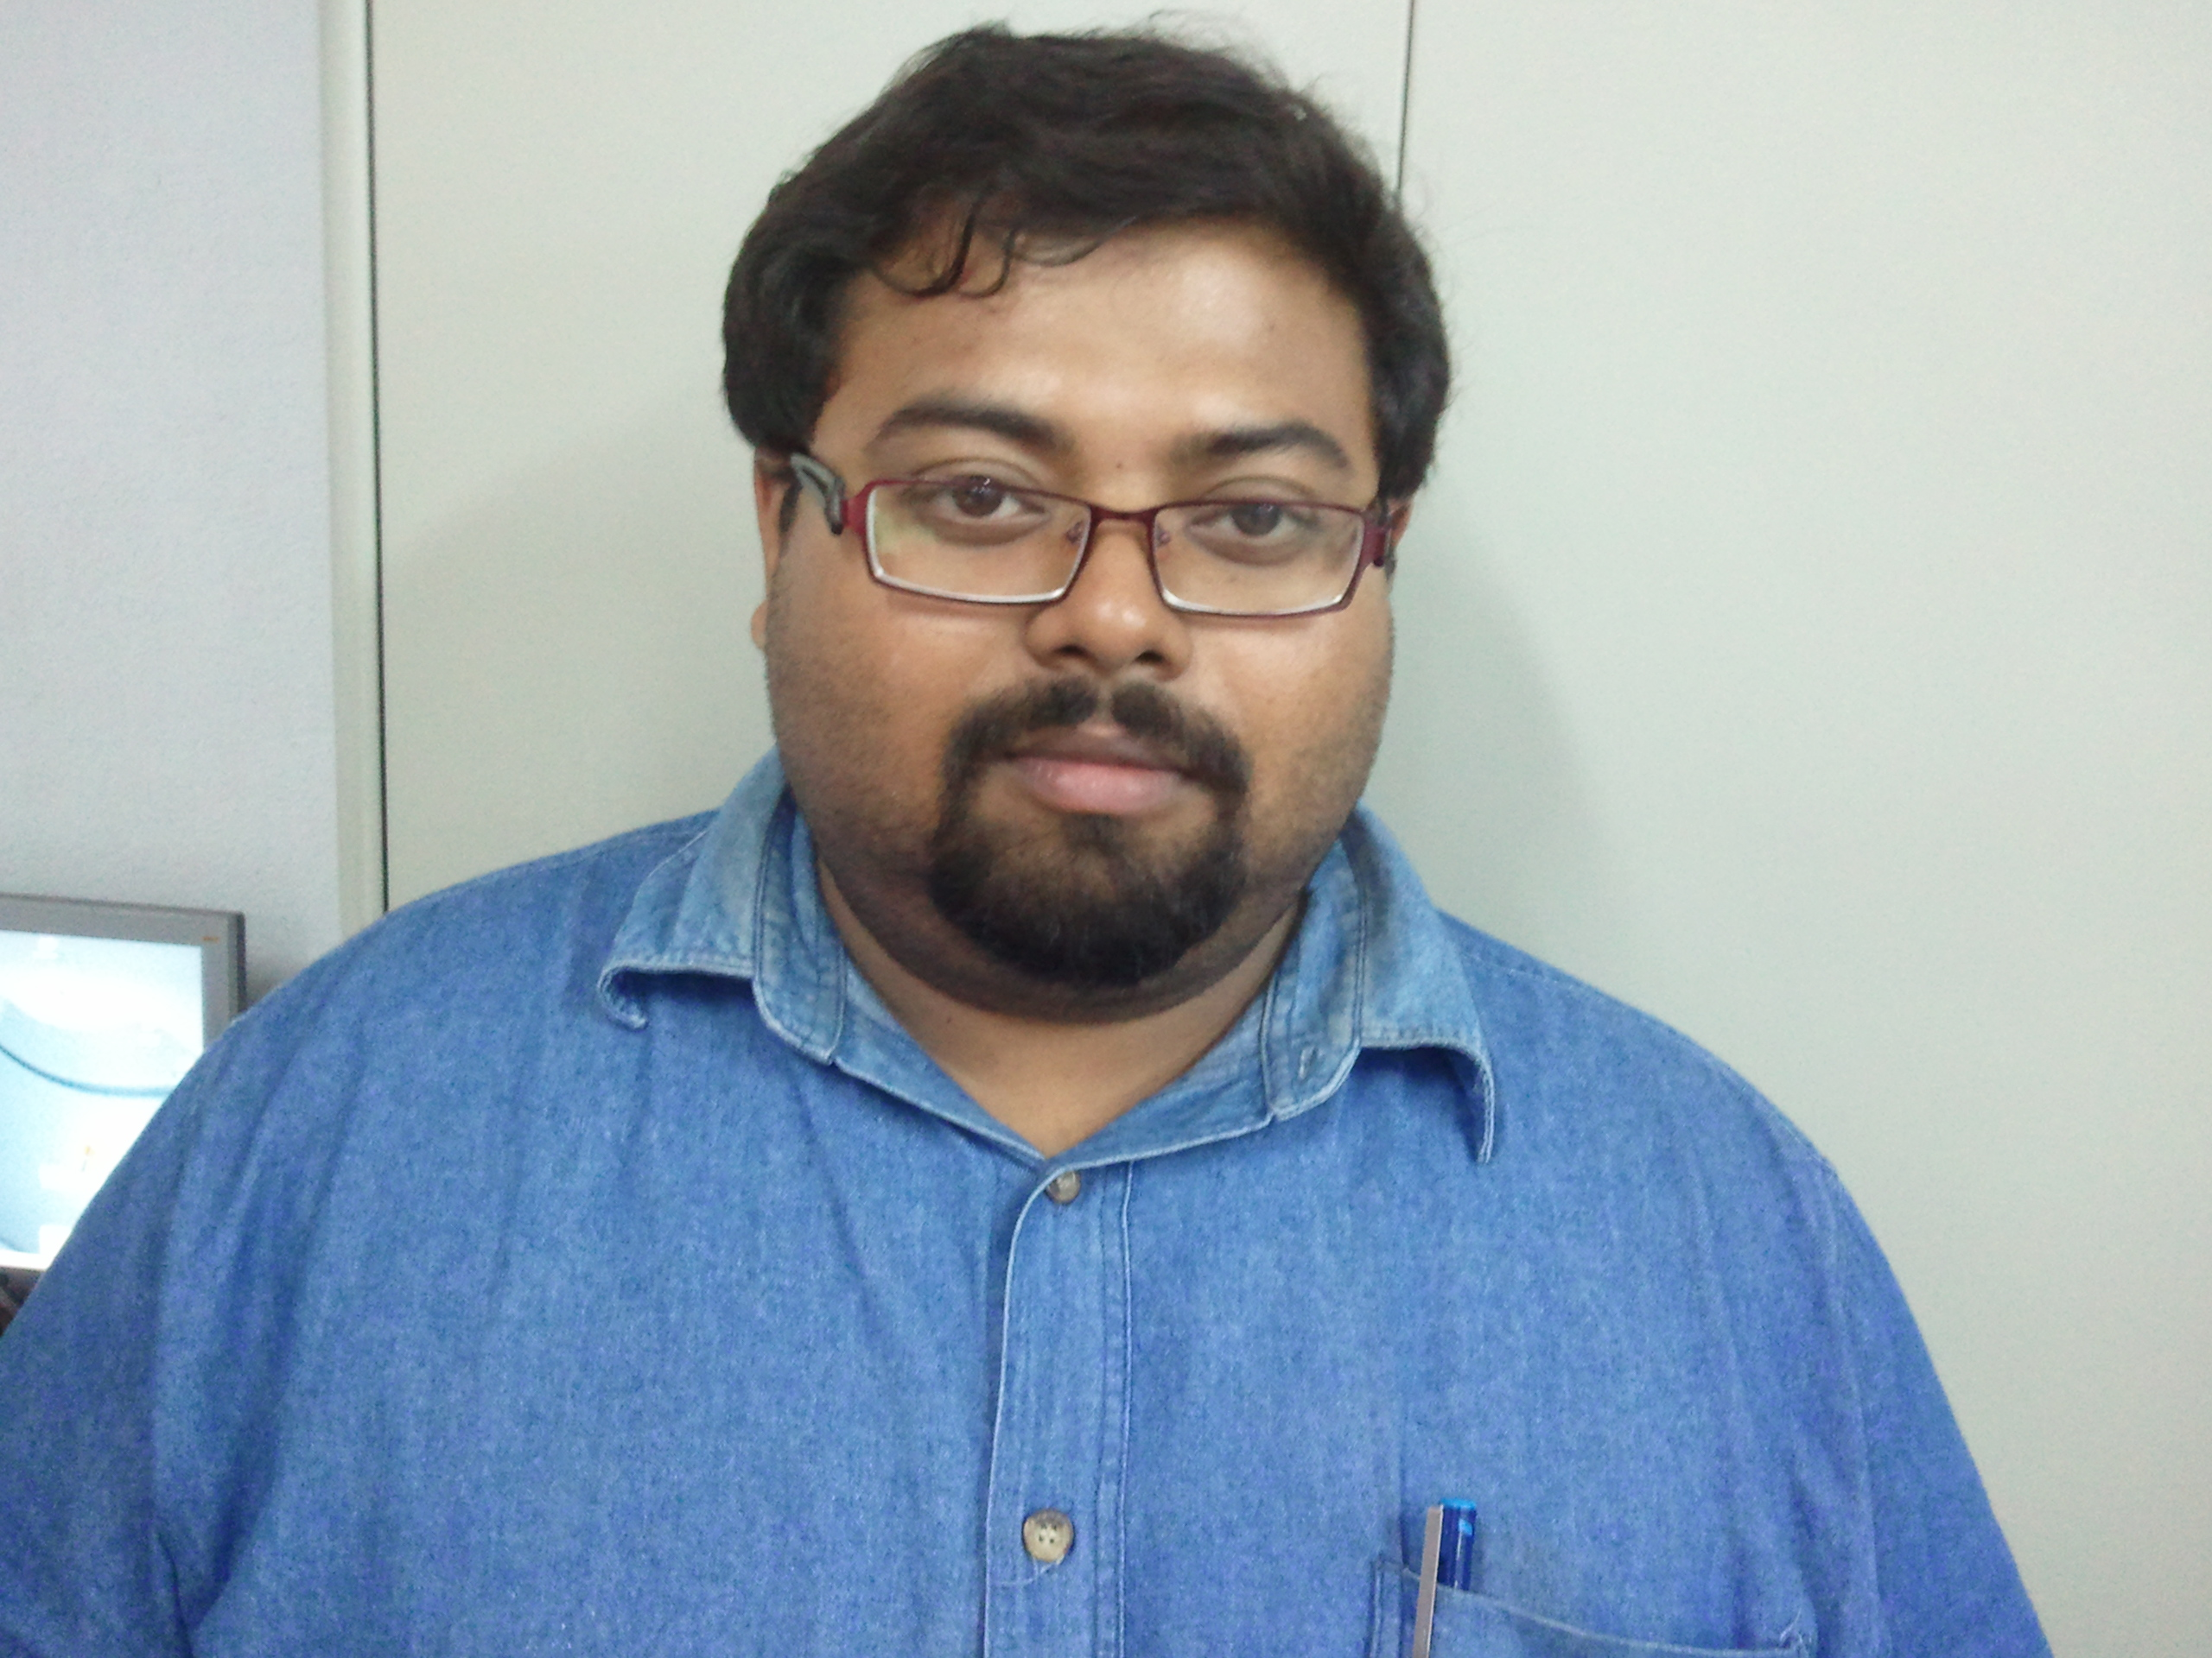
Designation: | ASSISTANT PROFESSOR
Department: | COMPUTER APPLICATIONS
Date of Joining the Institution: | 6 APRIL 2004
Qualification with Class Grade | UG | PG | PHD
 | BSc (Hons) Computer Science and Software Engineering (Birmingham, UK), 2:1 | Advanced MSc in Computer Science (Birmingham, UK)  Passed with 170 credits
Total Experience in years | Teaching | Industry | Research
 | 14 | 3
Papers Published | National |  | International
 | 3 (2 presented only) |  | 1 presented only
PhD Guide? Give field & University | Field |  | University
PhDs/ Projects Guided | PhDs: |  | Projects at Masters Level
 |  |  | More than 20
Books Published/IPRs/ Patents
Professional Memberships
Consultancy Activities
Awards
Grants Fetched
Interaction with Professional Institutions

