Name of Teaching Staff: | SUDIPTA BARDHAN |  | 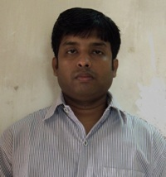Photograph
Designation: | Assistant Professor
Department: | Instrumentation & Control Engg.
Date of Joining the Institution: | 10.08.2009
Qualification with Class Grade | UG | PG | PHD
 | 1st | 1st | Pursuing
Total Experience in years | Teaching | Industry | Research
 | 11 yrs
Papers Published | National |  | International
 | 1 |  | 5
PhD Guide? Give field & University | Field |  | University
 | Graphene Transistor |  | IIEST, Shibpur
PhDs/ Projects Guided | PhDs: |  | Projects at Masters Level
Books Published/IPRs/ Patents
Professional Memberships
Consultancy Activities
Awards
Grants Fetched
Interaction with Professional Institutions

