Name of Teaching Staff: | PRIYANKA RAKSHIT |  | 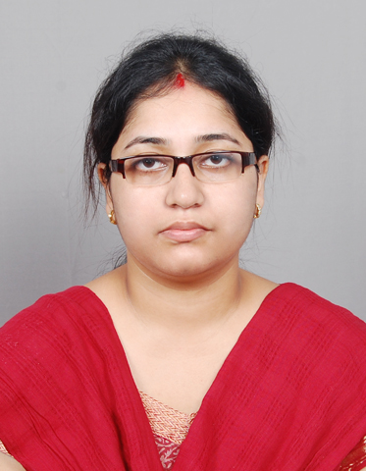
Designation: | ASSISTANT PROFESSOR
Department: | ICE
Date of Joining the Institution: | 16/02/2010
Qualification with Class Grade | UG | PG | PHD
 | B.Tech(7.71) | M.Tech(8.3)
Total Experience in years | Teaching | Industry | Research
 | 6 yrs
Papers Published | National |  | International
PhD Guide? Give field & University | Field |  | University
PhDs/ Projects Guided | PhDs: |  | Projects at Masters Level
Books Published/IPRs/ Patents
Professional Memberships
Consultancy Activities
Awards
Grants Fetched
Interaction with Professional Institutions

