Name of Teaching Staff: | NIBEDITA GHOSH |  | 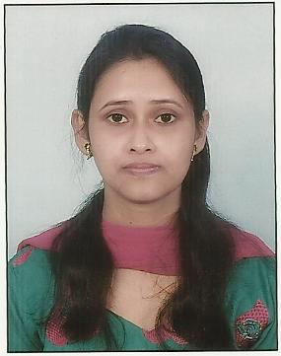
Designation: | Asst Prof.
Department: | Electrical Engineering(EE)
Date of Joining the Institution: | 01.07.2014
Qualification with Class Grade | UG | PG | PHD
 | B.Tech  Class/div -1st | M.Tech  Class/div-1st
Total Experience in years | Teaching | Industry | Research
 | 2
Papers Published | National |  | International
 |  |  | 1
PhD Guide? Give field & University | Field |  | University
PhDs/ Projects Guided | PhDs: |  | Projects at Masters Level
Books Published/IPRs/ Patents
Professional Memberships
Consultancy Activities
Awards
Grants Fetched
Interaction with Professional Institutions

