Name of Teaching Staff: | KEKA RANA |  | 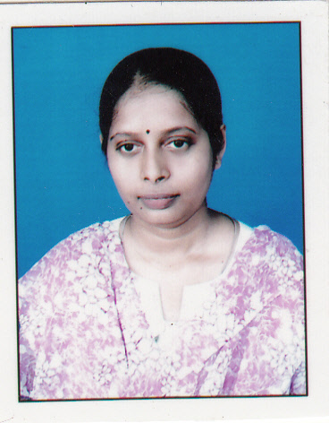
Designation: | Assistant Professor
Department: | Chemical Engineering
Mobile No.: 9735206244 | Email-id: kekarana28@gmail.com
Date of Joining the Institution: | 12/06/09
Qualification with Class Grade | UG | PG | PHD
 | 1st Class | 1st Class | Pursuing
Total Experience in years | Teaching | Industry | Research
 | 10 yrs |  | 7 yrs
Papers Published | National |  | International
 | 01 |  | 3
PhD Guide? Give field & University | Field |  | University
 | Membrane Separation, Waste water treatment
PhDs/ Projects Guided | PhDs: |  | Projects at Masters Level
 |  |  | 01
Books Published/IPRs/ Patents
Professional Memberships | Life member, IIChE (Membership No. - LAM 37868); Associate member, IEI (AM175452-4)
Consultancy Activities
Awards | Received Gold Medal for holding First Class, First position in M.Tech in Chemical Engg., Calcutta University.
Grants Fetched
Interaction with Professional Institutions | Indian Institute of Chemical Engineers (IIChE), The Institute of Engineers (India)(IEI)

