Name of Teaching Staff: | Dr. BISWAJIT MANDAL |  | 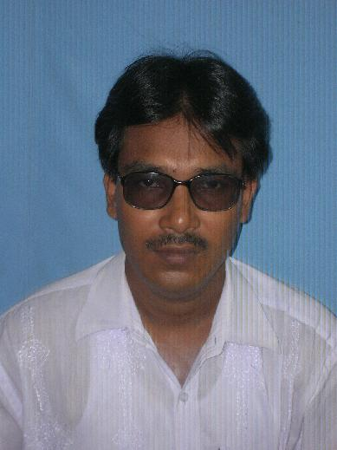
Designation: | Associate professor
Department: | Chemical Engineering
Date of Joining the Institution: | 01/06/2006
Qualification with Class Grade | UG | PG | PhD
 | 1st | 1st | Awarded
Total Experience in years | Teaching | Industry | Research
 | 12+ years | 1.5 years | 13+ years
Papers Published | National |  | International
 | 1 |  | 10
PhD Guide? Give field & University | Field |  | University
PhDs/ Projects Guided | PhDs: |  | Projects at Masters Level
 |  |  | 4
Books Published/IPRs/ Patents | Two
Professional Memberships | one
Consultancy Activities | one
Awards | one
Grants Fetched | Institute grants for research on alternative fuel.
Interaction with Professional Institutions | one
Patent | one

