Name of Teaching Staff: | Debadatta Ghosh |  | 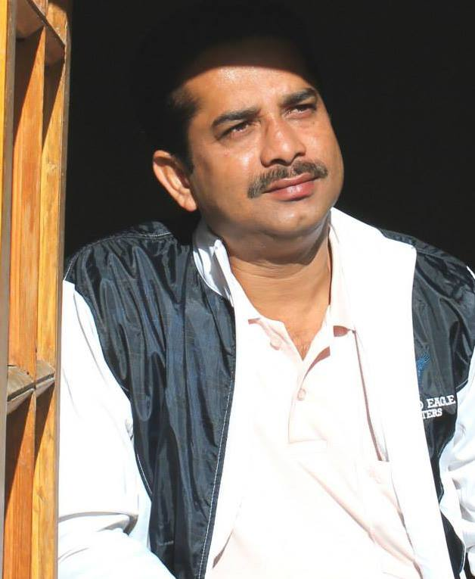aph
Designation: | Associate Professor-EIE & In Charge Corporate Relations
Department: | Applied Electronics and Instrumentation Engg
Date of Joining the Institution: | 02/07/2003
Qualification with Class Grade | UG | PG | PHD
 | B.TECH , 1st Class | M.TECH,1st Class
Total Experience in years | Teaching | Industry | Research
 | 18 | 7 | 2
Papers Published | National |  | International
 | 2
PhD Guide? Give field & University | Field |  | University
PhDs/ Projects Guided | PhDs: |  | Projects at Masters Level
Books Published/IPRs/ Patents
Professional Memberships
Consultancy Activities | Consultancy executed with Haldia Dock Complex
Awards
Grants Fetched
Interaction with Professional Institutions

